Supporting information for

National and county life expectancy loss due to particulate matter pollution in the USA

James E. Bennett†, Helen Tamura-Wicks†, Robbie M. Parks, Richard T. Burnett, C. Arden Pope III, Matthew J. Bechle, Julian D. Marshall, Goodarz Danaei, Majid Ezzati
† Equal contribution, listed alphabetically

S1 Text. Detailed specifications of statistical models.
We formulated and implemented four Bayesian spatio-temporal models to directly estimate the effect of PM_{2.5} concentration on cardiorespiratory diseases death rates at the county level. All analyses were done separately by sex and age group (five year age groups from birth to 85 years, and 85 years and older) because death rates vary by age group and sex, as might their associations with air pollution[1].

The four models had similar structures, but differed in the extent of adjustment for county characteristics that may also influence mortality, ranging from unadjusted to restrictive as described below and shown in Table S1. Specifically, for a given county, sex, and age group, the number of deaths in each year follows a Poisson distribution:
$${deaths}_{county-year}\sim Poisson({death rate}_{county-year}∙{population}_{county-year})$$
In all four models, log-transformed death rates were modelled as a sum of components that depend on time and air pollution, with some models also including terms for other time-varying county characteristics. All models contained terms to capture the overall level and rate of change of mortality, with $α_{0}$ as the common intercept for log-transformed death rates, and $β_{0}$the common time slope. Non-linear trends were captured by a first-order random walk $ν_{year}$[2]. All models also included a term that relates log-transformed death rate to county PM_{2.5} concentration, with the coefficient $γ$ representing the logarithm of the rate ratio per 1 μg/m³ higher concentration. $ε_{county-year}$is an over-dispersion term that captures the variation unaccounted for by other terms in the model, and is modelled as $N\left(0,σ_{ε}^{2}\right)$.

The unadjusted model did not include any terms related to county characteristics. The covariate model included terms for seven time-varying county level covariates $X_{i-county-year}$ ($i$=1…7) (per capita income; percentage of population whose family income is below the poverty threshold, who are of Black race, who have graduated from high-school, who live in urban areas, and who are unemployed; and a proxy for cumulative smoking) to account for other potential determinants of mortality with associated covariate-specific slopes, $θ_{i}$. This model is equivalent to the approach used by cohort studies, which typically adjust for baseline characteristics of subjects.

The covariate-and-county model also included county-specific random intercepts ($α_{county}$), which largely removes systematic variations in death rates and PM_{2.5} concentration across counties, hence implicitly adjusting for unobserved characteristics that systematically lead to higher or lower pollution and mortality in each county. In this model, the mortality effects of air pollution are largely inferred through cross-county differentials in changes in death rates and PM_{2.5} concentrations over time. The restrictive model included both county-specific random intercepts and random slopes ($β_{county}$), hence also implicitly adjusting for linear differential change in death rates and PM_{2.5} concentrations across countries and relates changes in PM_{2.5} concentration to changes in death rates, after removing linear trends in mortality and pollution. By design, this model leaves little spatial or temporal variation in death rates to be associated with PM_{2.5}. The county random intercepts and slopes were modelled using a conditional autoregressive (CAR) structure that (empirically) allows for death rates to be more similar across neighbouring counties than those that are further away.

We fitted the models using integrated nested Laplace approximation (INLA), using the R-INLA software, which offers orders of magnitude of computational efficiency improvement in Bayesian inference compared to traditional MCMC for latent Gaussian models. As in previous work[3], weakly informative hyper-priors of logGamma(1, 0.001) were specified on the logarithm of the precisions of the random effects so that the parameter estimates were data driven.

We used the observed age-specific death rates to calculate life expectancy for each county or merged county unit, using standard life table techniques[4]. We used the Kannisto-Thatcher method to expand the terminal (85 years and older) age group of the life table[5]. This method is designed for use in low-mortality populations and is used by the UN Population Division and the World Health Organization[6]. We calculated life expectancy under the counterfactual scenario of alternative PM_{2.5} concentration (e.g., the lowest observed concentration) by using the above-mentioned rate ratios to calculate the reduction in the number of deaths from cardiorespiratory diseases in each age group if PM_{2.5} concentrations were at their alternative level[7], e.g. 2.81 μg/m³. The difference between the observed and counterfactual life expectancy measures the contribution of PM_{2.5} pollution to life expectancy loss, see Fig 2 and 3 in the main paper. For the contribution of PM_{2.5} reduction to life expectancy gain from 1999 to 2015, we calculated 1999 life expectancies using observed death rates as well as those expected if PM_{2.5} concentration in each county had been at its 2015 level.

S1 Table. Models used for relating county death rates to PM_{2.5} concentrations.

Model |  | Common terms |  |  | County terms |  |  |  | Pollution terms |  |  |  | Covariates |  | Over-dispersion
Unadjusted | $\log\left({death rates}_{county-year}\right)=$ |  | $$α_{0}+β_{0}∙year+ν_{year}$$ |  |  |  |  | + |  | $$γ∙{PM}_{county-year}$$ |  |  |  |  |  | + | $$ε_{county-year}$$
Covariate | $\log\left({death rates}_{county-year}\right)=$ |  | $$α_{0}+β_{0}∙year+ν_{year}$$ |  |  |  |  | + |  | $$γ∙{PM}_{county-year}$$ | + | $\sum_{i=1}^{i=7}{θ_{i}∙X_{i-county-year}}$ |  |  |  | + | $$ε_{county-year}$$
Covariate-and-county | $\log\left({death rates}_{county-year}\right)=$ |  | $$α_{0}+β_{0}∙year+ν_{year}$$ |  | + | $$α_{ccounty}$$ |  | + |  | $$γ∙{PM}_{county-year}$$ | + | $\sum_{i=1}^{i=7}{θ_{i}∙X_{i-county-year}}$ |  |  |  | + | $$ε_{county-year}$$
Restrictive | $\log\left({death rates}_{county-year}\right)=$ |  | $$α_{0}+β_{0}∙year+ν_{year}$$ |  | + | $α_{ccounty}+β_{county}∙year$ |  | + |  | $$γ∙{PM}_{county-year}$$ | + | $\sum_{i=1}^{i=7}{θ_{i}∙X_{i-county-year}}$ |  |  |  | + | $$ε_{county-year}$$

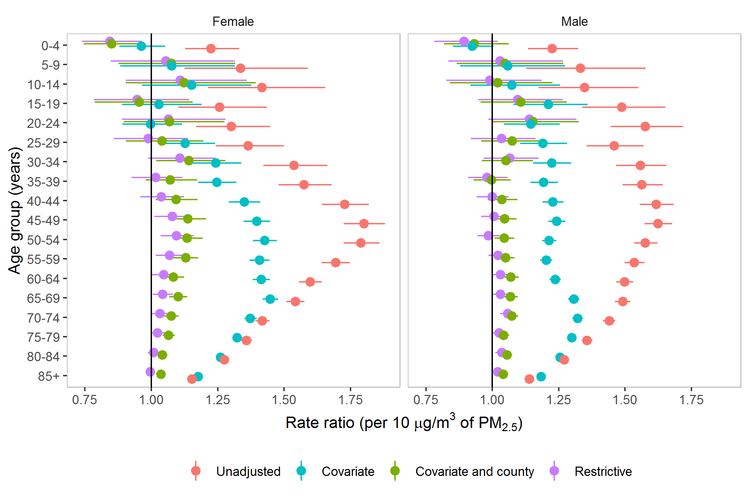

S1 Fig. Sex and age group specific rate ratios per 10 $μg/m^{3}$ of PM_{2.5} for cardiorespiratory deaths. The rate rations were estimated from four different Bayesian spatio-temporal models described in Statistical Methods.

References
1. Crouse DL, Peters PA, Hystad P, Brook JR, van Donkelaar A, Martin RV, et al. Ambient PM2. 5, O3, and NO2 exposures and associations with mortality over 16 years of follow-up in the Canadian Census Health and Environment Cohort (CanCHEC). Environ Health Persp. 2015;123(11):1180.
2. Rue H, Held L. Gaussian Markov random fields: theory and applications: CRC press; 2005.
3. Kontis V, Bennett JE, Mathers CD, Li GQ, Foreman K, Ezzati M. Future life expectancy in 35 industrialised countries: projections with a Bayesian model ensemble. Lancet. 2017;389(10076):1323-35.
4. Preston S, Heuveline P, Guillot M. Demography: measuring and modeling population processes2000.
5. Thatcher AR, Kannisto V, Vaupel JW. The force of mortality at ages 80 to 120. 1998.
6. WHO. WHO methods and data sources for life tables 1990-2016 2018 [Available from: http://www.who.int/healthinfo/statistics/LT_method.pdf.
7. Danaei G, Rimm EB, Oza S, Kulkarni SC, Murray CJL, Ezzati M. The promise of prevention: the effects of four preventable risk factors on national life expectancy and life expectancy disparities by race and county in the United States. Plos Med. 2010;7(3).

